
Applicant guide for using the online application system
Table of Contents
Purpose 2
Welcome to Kelly’s Online Application System 2
Resume Section 4
Contact Information Section 5
Education Section 7
Work Experience Section 8
Skills Section 10
Preferences Section 15
Review and Submit Section 17
Thank You Section 18
Questions/Contact 18

Purpose
Thank you for choosing Kelly Services as a potential employer! Please refer to this document as you complete and submit your online application to the Kelly branch.

Welcome to Kelly’s Online Application System
- To enable access to Kelly’s Online Application System (OAS), your Kelly branch first needs to enter some preliminary information about you into our database (e.g., your name, e-mail address, etc). Using this information, our system is able to send you a personalized invitation via e-mail to access the Online Application System (OAS).  - The message you receive via e-mail will include the information you need to log on to the OAS: a hyperlink to the OAS, your user name (i.e., a unique numerical number), and a system-generated password.  - To begin the OAS log on process, click the hyperlink in the e-mail message.  Tip: If the link does not work, enter the following URL in your Internet Browser: https://application.kellyservices.com  - Using the log on information provided in the e-mail message (i.e., the User Name and Password), log on to the OAS.  Note: For your protection, our system-generated passwords are complex. If you have trouble logging on, it may be necessary to copy the password from the e-mail message, and paste it directly into the Password field.  - After logging on using the system-generated password, you will be prompted to change your password.  - In the Old Password field, enter the system-generated password that you received in the e-mail message from Kelly.  - In the New Password field, create and enter a new password.  - In the Confirm New Password field, enter the same password you entered in the New Password field.  Note: Your new password must be at least 8 characters long, and contain characters from three (3) of the following categories: uppercase letters, lowercase letters, digits, or non-alphabetic characters (e.g., %).  - After creating the new password, you are prompted to log on to the OAS again using:  - The numerical User Name provided in the OAS invitation.  - The new password that you created. | 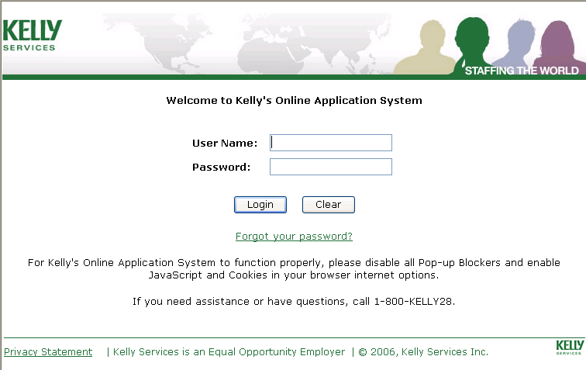  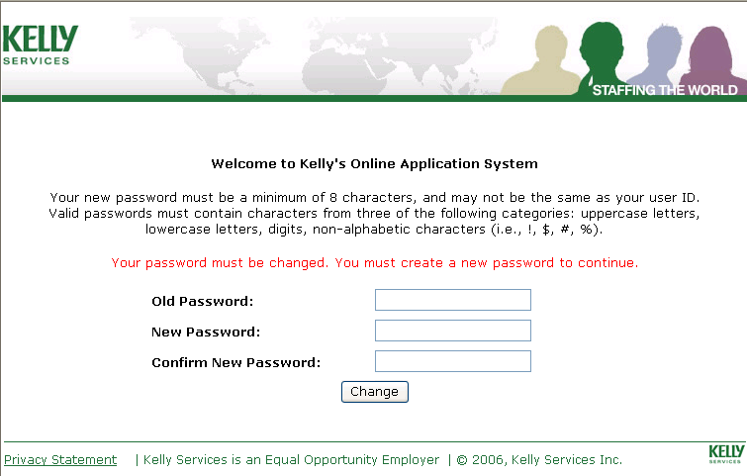

Welcome to Kelly’s Online Application System Screen (Continued)
- After successfully logging on using your new password, the Welcome screen displays, and you are asked to select a Security Question and enter an answer to that question. This information is used if you forget your password in the future and want to reset it from the log on page.  - Security Question–Click the drop-down list and select a security question.  - Answer–Enter the answer to your security question.  Remember: If you need to reset your password in the future, the answer to your security question is case-sensitive!  - Click Continue to begin the online application.  Notes:  - From this point forward, two new links are available to you in the upper-right corner of the screen: Help and Log Out.  - Click the Help link if you want to use Kelly’s online help text.  - Click Log Out if you need to log off of the application.  Note: If you log off prior to submitting your application, your application information may not be saved. | 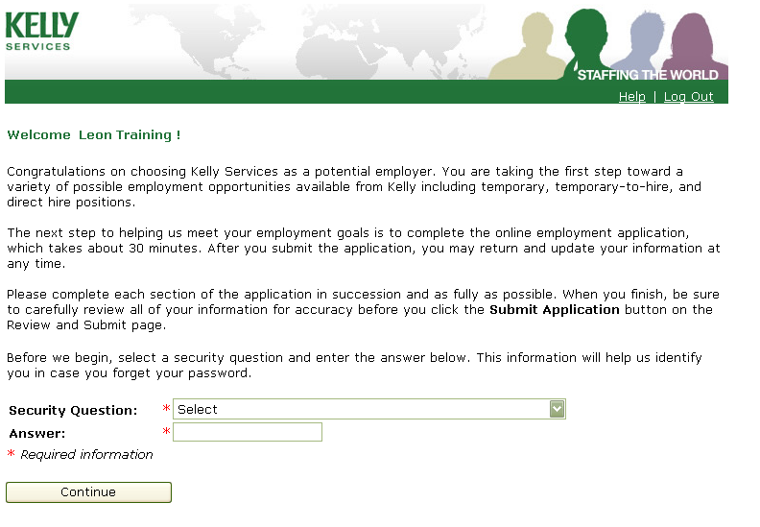      

Resume Section
If you choose to attach a résumé, you may use the auto-fill feature to let the OAS pre-populate some of your application information!  Note: If you do not have an electronic résumé to attach, click Continue at the bottom of the screen to move to the next section of the application.  - In the Choose a Resume section, click Browse to locate and select the résumé from your PC. Once the résumé has been selected, the résumé path will display beside the Browse button.  - In the Attach a Resume section, enter a brief description of your résumé in the Description field (e.g., Administrative), and then click Attach.  - Repeat Steps 1 and 2 if you want to attach more than one résumé.  Note: You may attach up to three résumés in the OAS. If you have more than three résumés, give the additional résumés directly to your Kelly branch (e.g., via e-mail).  - In the Attached Resume(s) section, click the Auto Fill indicator beside the résumé you want the OAS to use during the auto fill process.  Notes:  - If you have attached only one résumé, the system will automatically select the Auto Fill indicator for you.  - If you have attached more than one résumé, click the Auto Fill indicator beside the résumé you want the OAS to use during the auto fill process.  - Click Continue.  - After a few moments, you will receive a confirmation that your résumé was successfully uploaded using the auto-fill process. Click Continue.  Note: As you proceed, notice that certain information (from your résumé) pre-populated within your online application (e.g., education information, previous employment, etc). Carefully review any pre-populated information. If necessary, edit and/or update the information before submitting your application. | 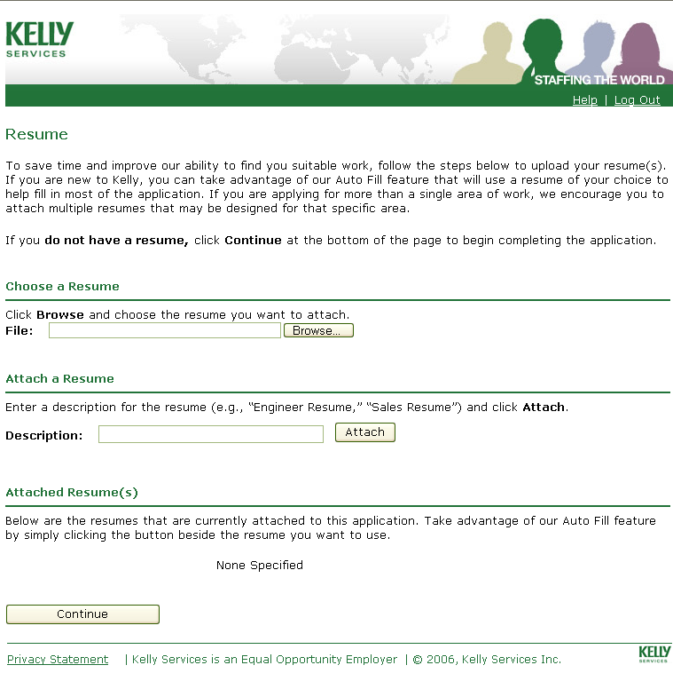      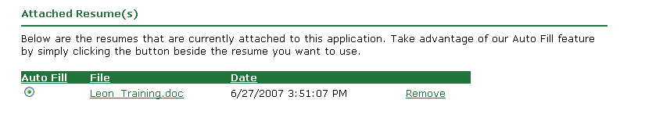      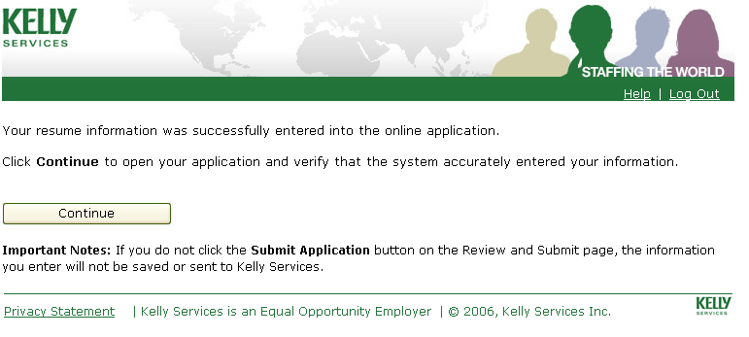  

Contact Information Section
Use this section to provide Kelly with your general contact information.  Note: Review any information that pre-populated from the auto-fill process, and edit it as necessary.  Name If applicable, specify a preferred name that differs from your legal name  - If you have a preferred name, (e.g., your legal name is Robert, but your nickname is Bob) enter it in the Preferred Name field. Otherwise, leave this field blank and go to the Other Names section.  Note: To edit/update your first name, middle initial or last name, contact your Kelly branch.  Other Names Add other names you have previously used (e.g., maiden name)  - Click New to add another name used.  - Complete the Other Name, From and To (i.e., date) fields.  - Click OK to save the name.  Addresses Information Enter all addresses you have used in the last 10 years  - If you used the auto-fill process, the address from your résumé may have already pre-populated. Click Edit to specify (i.e., in the Select the Address Type section) the address Type (e.g., Payroll Address), and to verify that the address is correct. Click OK to return to the Contact Information section.  - To add new/additional addresses, click New. The Add Address page displays. Complete the required fields, and click OK to return to the Contact Information section.  3. To remove an address, click Remove. Click OK to remove the address.  Notes:  - Remember to include all addresses you have used in the last 10 years.  - Once you submit your application, you are not able to edit or remove your current or payroll address from the OAS. Contact your Kelly branch, if you need to make a change. | 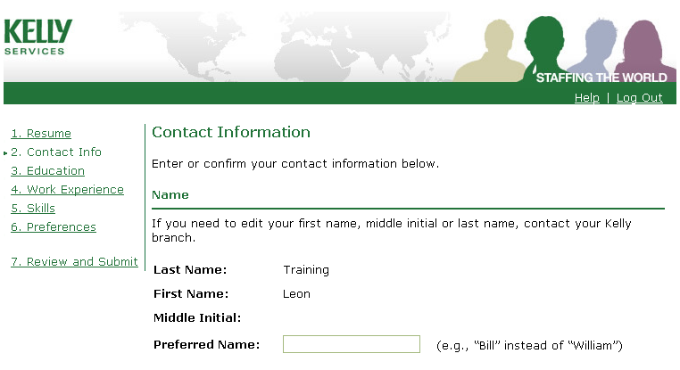  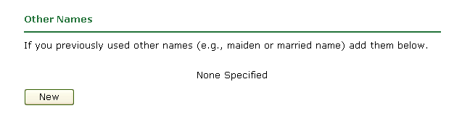  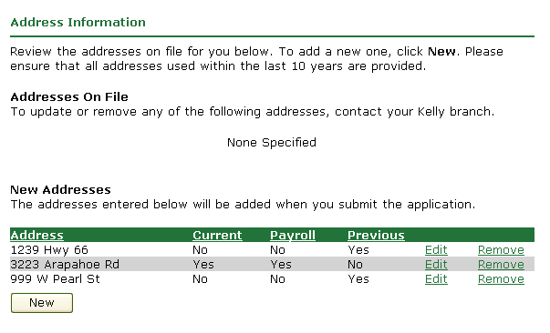

Contact Information Section (Continued)
Telephone Enter your telephone contact information  Note: The telephone number from your résumé may have pre-populated your application. It may be necessary to edit the telephone Type (e.g., Home).  - Click New to add a new telephone number.  - Click Edit to change the Number, Extension or Type (e.g., Cell). Click OK to save the change.  - Click Remove to delete a telephone number.  E-mail Address Use this section to provide your e-mail addresses  The e-mail address(es) that you provided to the Kelly branch will display in this field by default.  - Click New to add additional e-mail addresses.  - Click Edit to change the e-mail address or e-mail type (e.g., Personal). Click OK to save the change.  - Click Remove to delete an e-mail address. Click OK to remove the e-mail address.  - Click the Primary indicator beside the e-mail address you want the Kelly branch to use for e-mail communication.  Preferred Contact Method Designate the method you want Kelly to use first to contact you  - Select your preferred method form the drop-down list (e.g., Cell Phone).  Emergency Information Enter the contact information of the person Kelly should contact in the event of an emergency  - Click New to enter an emergency contact; include the telephone number and type. Click OK to save the information.  - Click Edit to update the contact information of an existing emergency contact. Click OK to save the change.  - Click Remove to delete an emergency contact. Click OK to remove the emergency contact.  - To go to the next section of the online application, click Next Section.  Note: From this point forward, you may also return to the previous section of the online application, by clicking the Previous Section button. Do not use the back and next buttons navigation buttons located at the top of the internet page. | 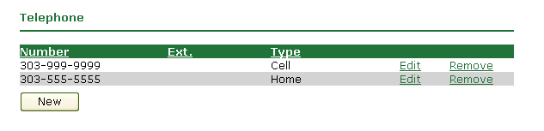  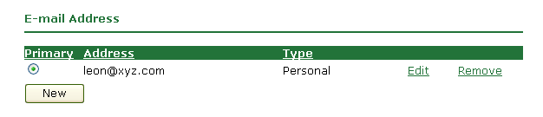  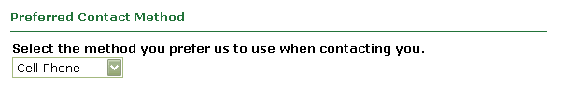  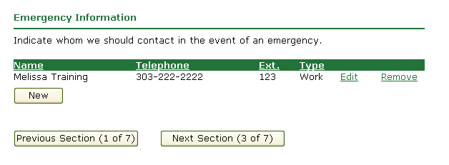

Education Section
Use this section to list your educational achievements.  - To add a new or additional school/institution or degree, go to Step 1.  - To edit existing information in this section (e.g., fields that pre-populated during the auto-fill process), go to Step 2.  Note: Although some of your educational information may have pre-populated during the auto-fill process, it is still necessary to click Edit to add other pertinent information (e.g., Major).  - Click New to add schools/institutions, or degrees. The Edit Schools/Institutions Attended page displays.  - Complete the fields/drop-down lists on this screen.  - In the Major section, if applicable, click New to add a major.  - Go to Step 3.  Notes:  - Before adding a Major, you must select a Discipline (e.g., Business).  - The OAS narrows the list of Majors by the Discipline selected. If your major does not display in the list, select a new Discipline.  - Click Edit to review pre-populated schools/institutions and complete and/or edit any of the information on the page. The Edit Schools/Institutions Attended pop-up window displays.  - Edit the applicable fields/drop-down lists (e.g., Discipline, Status, etc.)  - Go to Step 3.  - Click OK to save.  - When you are finished, click Next Section. | 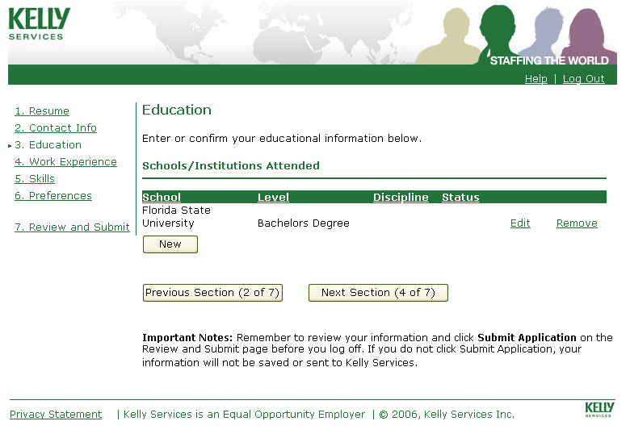  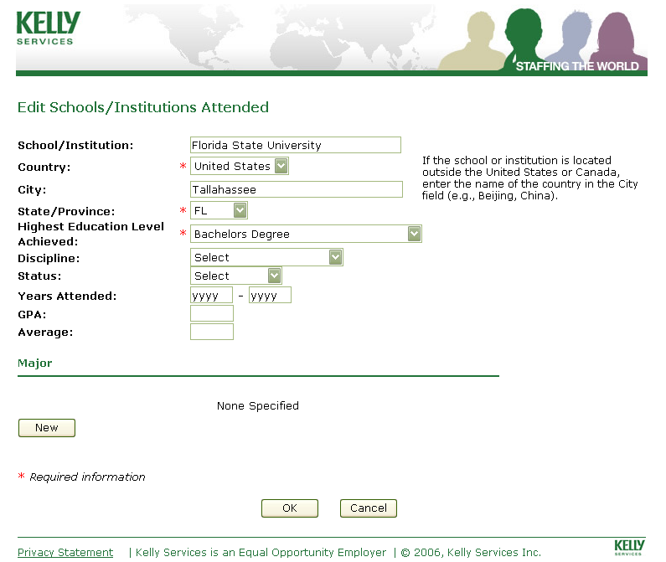

Work Experience Section
Current/Previous Employer Information Enter employment information for your last three employers  Notes:  - Although some of your work experience may have pre-populated during the auto-fill process, it is necessary to click Edit to add other pertinent information that did not populate from your résumé (e.g., the telephone number of the employer).  - When entering employment information, be as thorough as possible. This information helps Kelly find the best job matches for you.  - Click New to add employment information. The Add Previous/Current Employer Information pop-up window displays.  - Complete the fields.  - Go to Step 3.  - Click Edit to edit or add additional information to an existing employer. The Add Previous/Current Employer Information pop-up window displays.  - Edit the appropriate fields.  - Go to Step 3.  - Click OK to save the information you entered in the Add Previous/Current Employer Information pop-up window and return to the Work Experience page. | 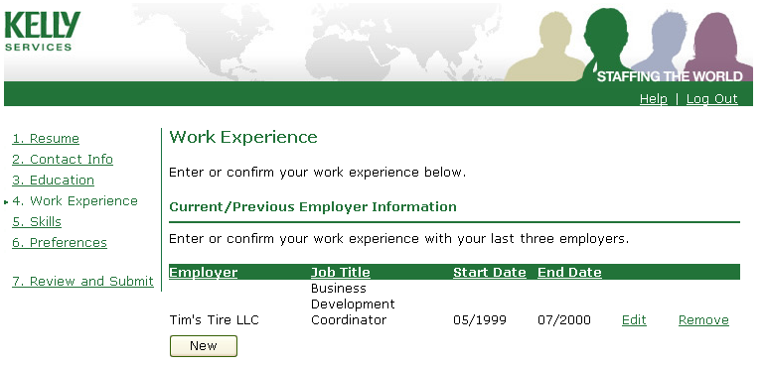  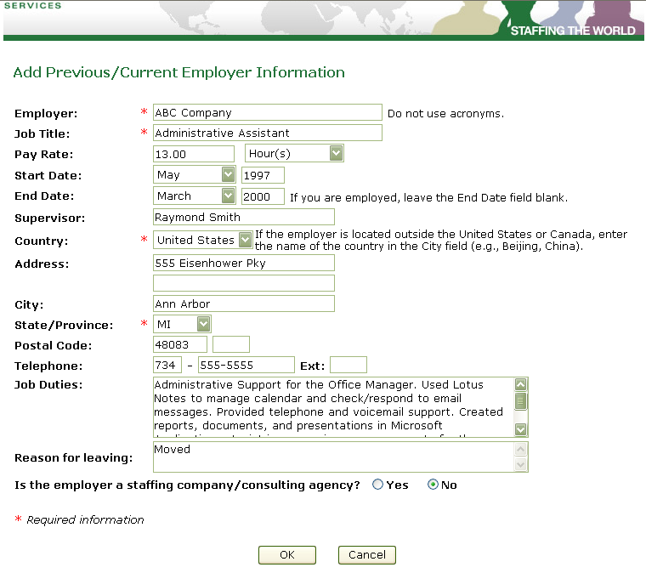

Work Experience Section (Continued)
Industries Enter your industry experience  - Click New to add the industries for your last three employers. Drop-down lists for the industry, subindustry, and years display.  - Select the appropriate Industry from the drop down listing.  - Select the appropriate subindustry from the drop-down listing.  - Select the number of years in the industry from the drop-down listing.  - Click OK when ready to save the information.  - Repeat until the industries for your last three employers have been captured.  - To edit the information on a specific line, click Edit. Click OK to save the change.  - To remove an industry, click Remove.  Kelly Experience Specify if you ever worked for Kelly Services before  - Select Yes or No.  References Enter the contact information for your references  Note: Please enter at least two references with telephone numbers.  - To add a new reference, click New. The Add References pop-up window displays.  - Complete the fields on the screen.  - Click OK to save the reference and return to the Work Experience section.  - To edit the information, click Edit. Click OK to save the change.  - When you are finished, click Next section. | 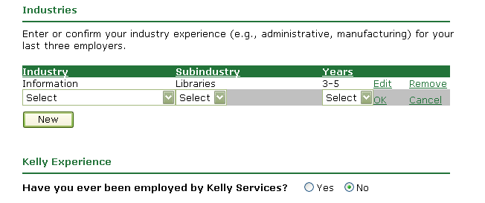  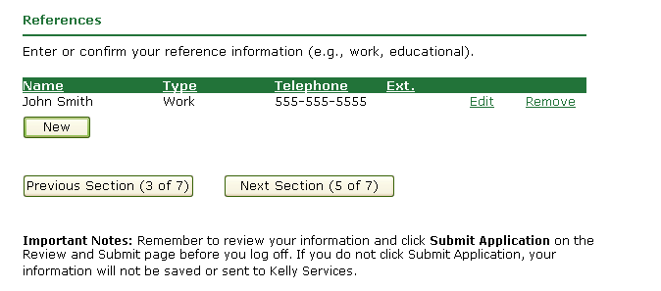  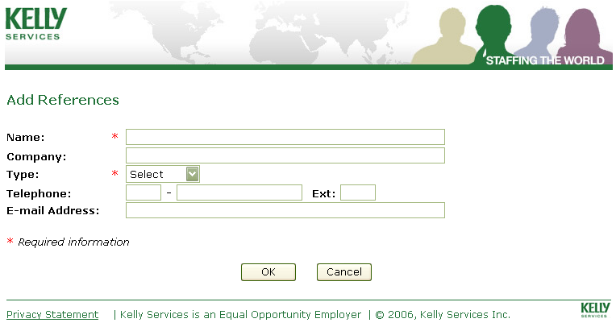

Skills Section
The Job Skills Section Use this section to capture your skills  - Click New to add the skills in which you have experience. The skills pop-up window displays. The skills pop-up window has three sections: Search for Skills, Edit Your Skills, and Select Your Skills.  - In the Search for Skills section, click the Type drop-down list, and select the appropriate type of work that best represents your overall skills (e.g., Office),  - Click Search.  Notes:  - The fastest way to find/add skills is to use the Type drop-down list. This reference guide contains instructions using this method.  - To search for a skill by keyword (e.g., Excel), enter the skill in the Keyword field, and click Search. If our system recognizes the skill, it will display in the Select Your Skills section. Select the indicator beside the skill, and then click Select.  - The first 10 skills related to the Type (e.g. Office) you selected now defaults in the Select Your Skills section.  - Review the skills, and select the indicator beside the skill(s) in which you have experience.  Note: If you do not have experience with any of the skills listed, go to Step 6.  - Click Select.  - Click >> Next to review the next group of skills.  - Repeat Steps 4-6 until all of the skills in this group have been reviewed. Then go to Step 8.  Notes:  - To review/select from a new grouping of skills (e.g., Call Center), go to Steps 2-7. When finished, go to Step 8.  - The Edit your Skills section displays all skills identified in the Select Your Skills section. Click Edit to enable the Level and Years drop-down lists.  - From the Level drop-down list, select the level of experience with the skill.  - From the Years drop-down list, select the length of time you have used the skill.  - Click OK to save the information.  - Repeat Steps a-c for all remaining skills. | 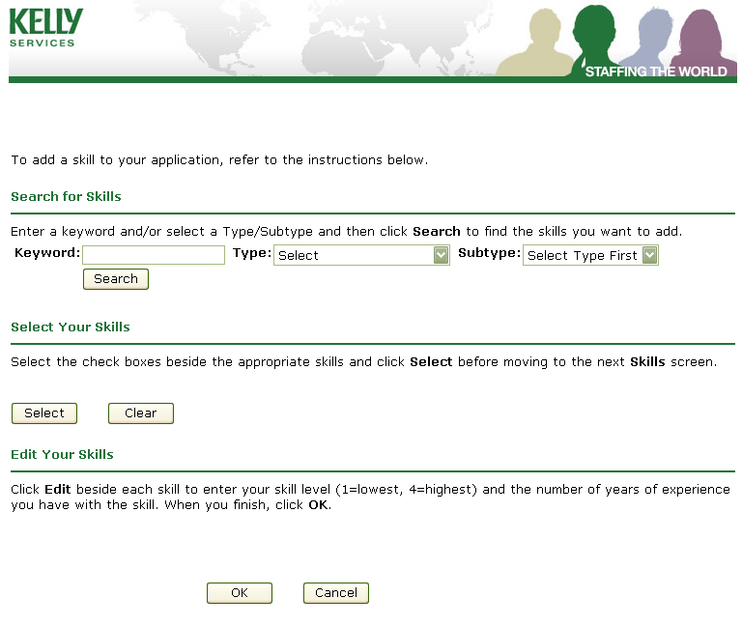  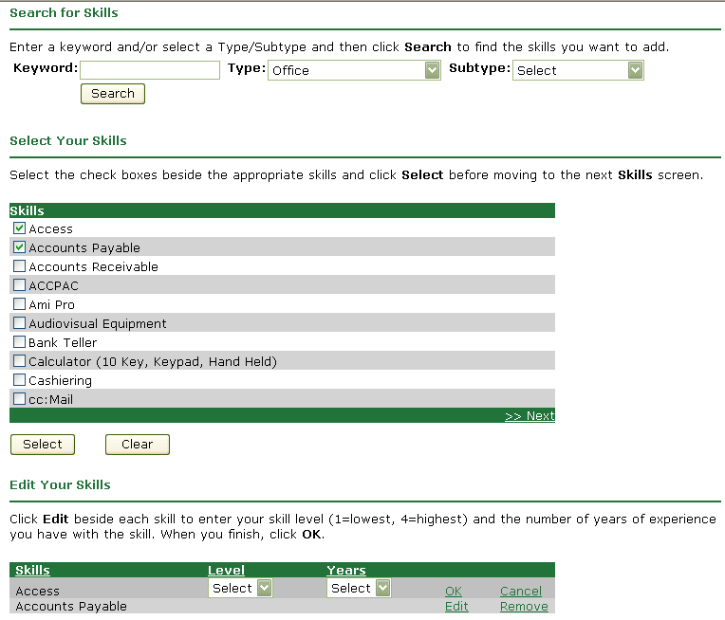

Skills Section (Continued)
- When you are finished adding your skills, click OK to close the Skills pop-up window and return to the Skills section of the application.  Note: The system will populate the information added on the Skills pop-up window to the Skills section.  Certifications/Credentials Use this section to add your Certifications/Credentials  - Click New to add the certifications and credentials that you have. The Add Certifications/Credentials pop-up window displays.  Note: This window has three sections: Search for Certifications/Credentials, Select Your Certifications/Credentials, and Add Your Certifications/Credentials.  - In the Search for Certifications/Credentials section, leave the Keyword field blank and click Search.  Note: This is the fastest way to view the complete listing of certifications/credentials. This reference guide contains instructions using this method. | 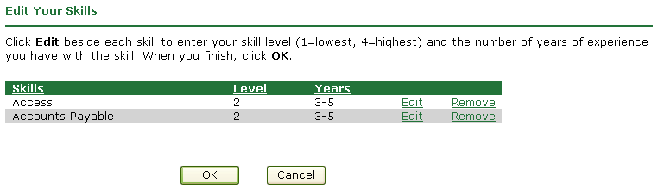  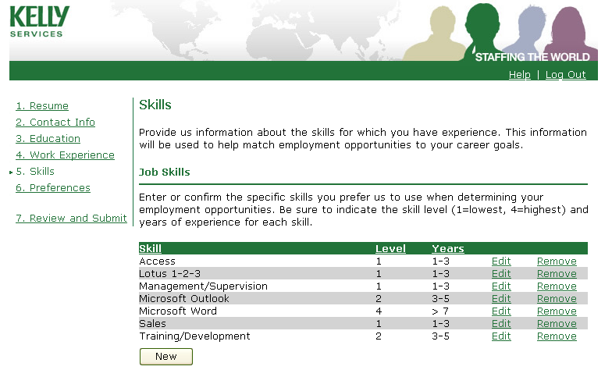  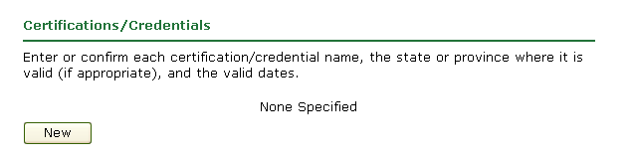  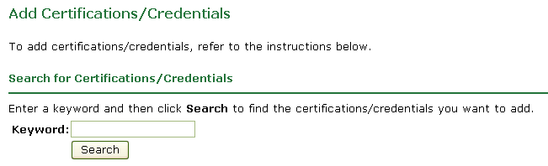

Skills Section (Continued)
- The first 10 certifications/credentials default in the Select Your Certifications/Credentials section.  - Review the certifications/credentials in this section, and select the indicator beside the certifications/credentials that you have.  Note: If you do not have the certifications/credentials listed, go to Step 6.  - Click Select.  - Click >>Next to review the next group of certifications/credentials.  - Repeat Steps 4-6 until all skills in the group have been reviewed. Then go to Step 8.  - The Edit Your Certifications/Credentials section displays all certifications/credentials you selected. Click Edit to open the Edit Certifications/Credentials screen.  - Complete the following fields  - Select a country from the Country drop-down list.  - Select a state or province from the State/Province drop-down list.  - In the Agency field, enter the name of the Agency which issued the certification/credential.  - In the Issued field, enter the date the certification/credential was issued (use mm/dd/yyyy format), or click the calendar icon to select the appropriate date.  - If applicable, in the Expires field, enter the date the certification/credential expires (use mm/dd/yyyy format), or click the calendar icon to select the appropriate date.  - Click OK to save the information, and return to the Skills section. | 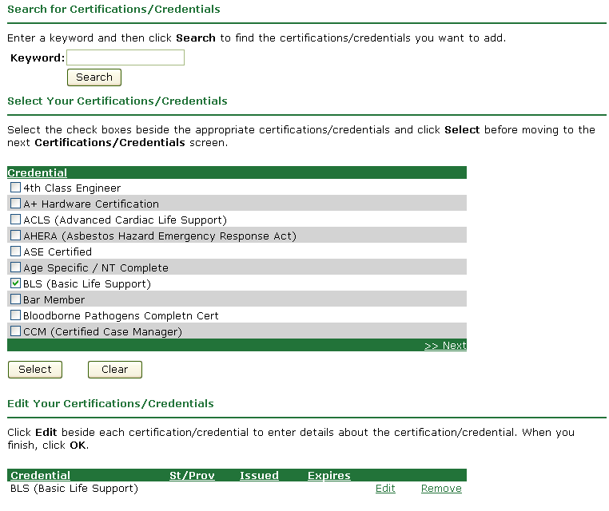  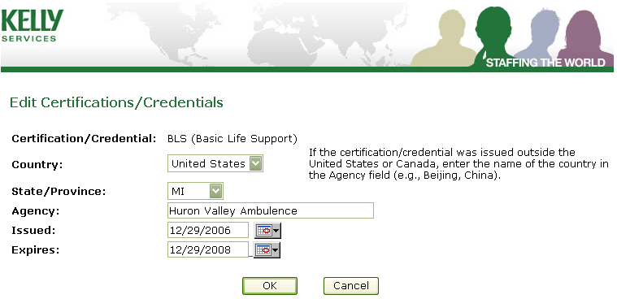

Skills Section (Continued)
Security Clearances  - To add a security clearance, click New.  - Click the Select drop-down list to select the appropriate security clearance level.  - To save the information, click OK.  - Repeat Steps a-b until all security clearances have been added.  Languages  - Click New to confirm the languages that you speak, read, and/or write. The Language pop-up window displays.  Note: The language pop-up window has three sections: Search for Languages, Select the Languages That You Speak, Read, and/or Write, and Edit the Selected Languages.  - In the Search for Languages section, leave the Keyword field blank, and click Search.  Note: This is the fastest way to view the complete listing of languages. This reference guide contains instructions using this method.  - The first ten languages default in the Language section.  - Review the languages in this section, and select the indicator beside the language(s) you speak, read, and/or write.  Note: If you do not speak, read, and or write these languages, go to Step c.  - Click Select.  - Click Next>> to review the next ten languages.  - Repeat Steps a-c until all languages have been reviewed and/or selected. Then, go to Step 4.  - The language(s) selected in the Language section now appear in the Edit the Selected Languages section.  - By default the system populates No in the Speak, Read, and Write columns. | 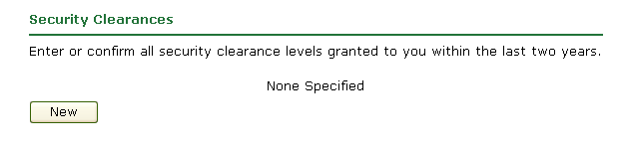  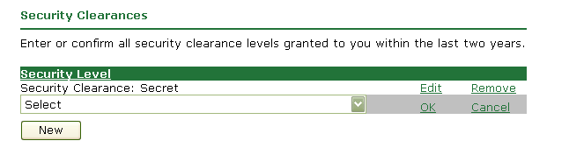  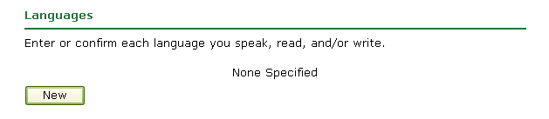  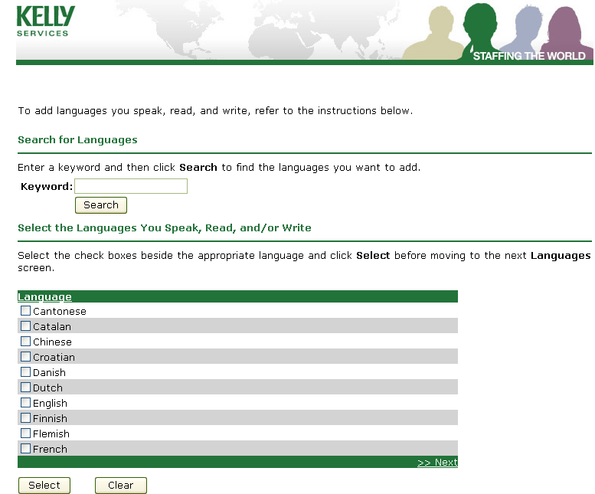  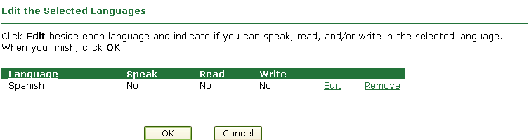

Skills Section (Continued)
- To update this information, click Edit.  - Select the indicators to specify that you speak, read, and/or write in the language. Leave the indicator deselected to specify that you cannot speak, read, and or write in the language.  - Click OK to save the information.  - Click OK to save the information, and return to the Skills section.  Miscellaneous Skills  - If applicable, use the free form section to enter any miscellaneous skills you would like to include with your online application.  - When you are finished, to save the information you’ve entered on the skills page and to continue with your online application, click Next Section. | 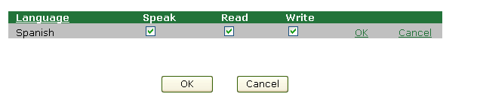  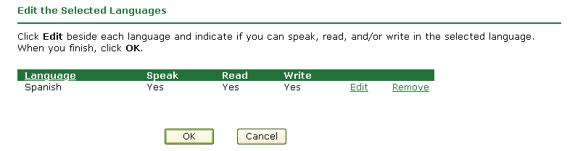  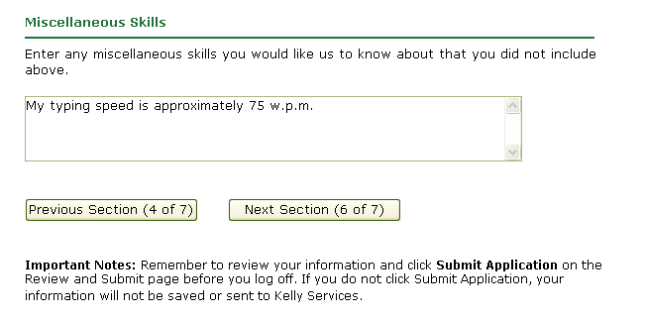

Preferences Section
Use the Preferences section to specify your work preferences.  - Review the employment options (i.e., Temporary, Temp-to-Hire, and Direct Hire) available in the Kelly Employment Options section. Select the indicators beside the employment options for which you want to be considered.  Note: This information helps Kelly find the best possible job matches for you. If applicable, select more than one employment option.  - In the Commute section, enter the maximum mileage and time you are willing to commute to work each day.  Note: Both fields accept only numerical characters (e.g., 30).  - Complete the Salary section.  - Enter your minimum salary requirement for assignments in a numerical format (e.g., if you are not willing to accept an assignment which pays less than $9/hr, enter 9).  - Select the unit of measure from the drop-down list [e.g., Hour(s)]. | 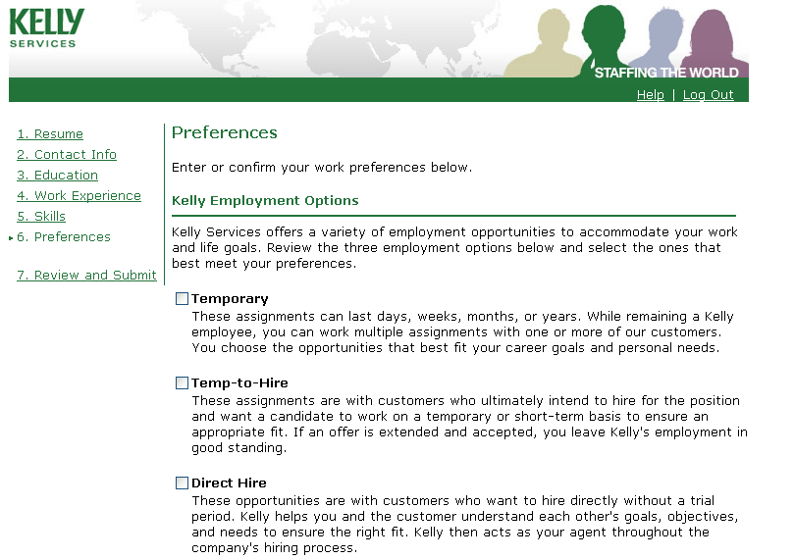  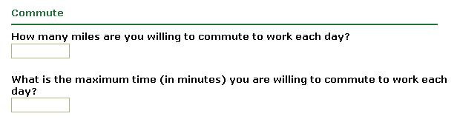  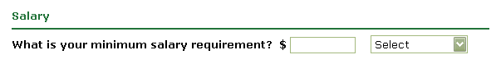

Preferences Section (Continued)
- Complete the Schedule section.  - Select the indicator(s) beside the day(s) you are available to work.  - Select the indicator(s) beside the schedule(s) (e.g., shift) you are available to work.  Note: Upon selecting at least one schedule, the What Schedule Would you Prefer indicators become enabled.  - If applicable, select your preferred schedule.  - Enter the earliest date you can begin working.  Note: You must use MM/DD/YYYY format.  - If you are interested in working part-time hours, select the indicator beside Yes.  Note: By default, the system selects the indicator beside No.  - In the free form area in the Career Objective section, enter either: a career objective, or the specific attributes you are looking for in an ideal position.  - By default, the system sets the indicators in the Travel, Relocation, and Seasonal Work section to No. As applicable, update the indicators.  - The Company Preferences section enables you to add specific companies that you would or would not like to work for.  - To add a company, click New.  Note: A new line item displays.  - In the Company field, enter the name of the company.  - In the Work Location field, enter the work location (i.e., city and state).  - To specify whether you would or would not like to work for the company, select the To Work or Not To Work indicator  - Click OK to save the information.  - Repeat Steps a-e until all company preferences have been added.  5. When finished, click Next Section. | 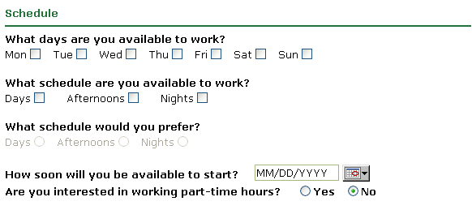  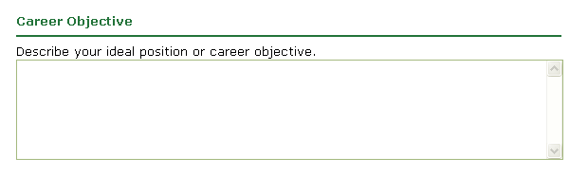  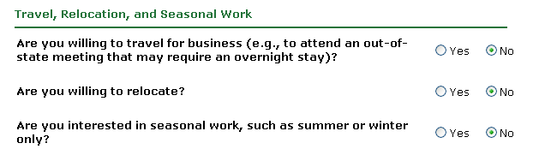  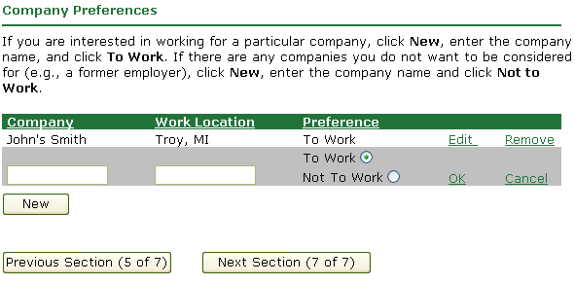

Review and Submit Section
Use the Review and Submit section to review all of the information that you entered in the Online Application System.  Note: If you want to print a copy of your online application, click the Print Friendly Page link located at the top of the page.  - To make changes to your application, click Edit to return to the appropriate section of the application.  - Update the applicable information.  - To return to the Review and Submit section, click the Review and Submit link located at the top left-hand side of the page.  - At the bottom of the Review and Submit page, complete the Federal Equal Employment Opportunity Information section.  Notes:  - Canadian Applicants - Select Decline to Disclose from both drop-down lists.  - U.S. Applicants - Select an appropriate value from the drop-down lists.  - When you are ready to submit your application to the Kelly branch, click Submit Application.  - Go to the Thank You section of this document for other very important information. | 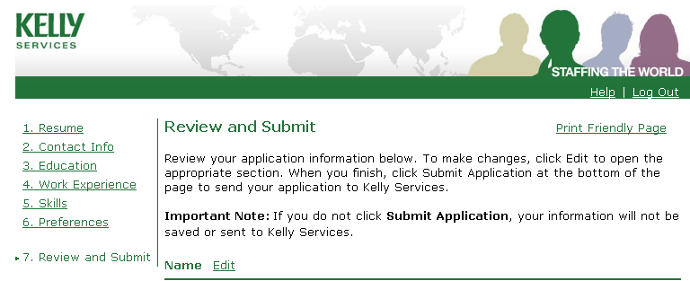  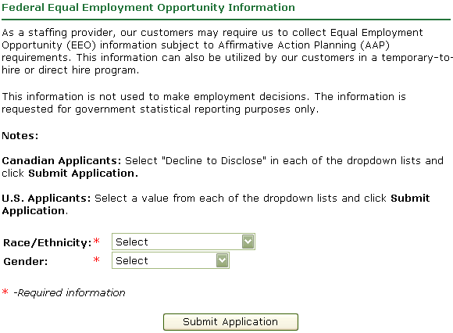

Thank You Section
When your online application has been successfully submitted to the Kelly branch, the Thank You section displays.  - If you want to refer a friend to Kelly, click the Refer a Friend link; the Refer a Friend page displays. Otherwise, go to Step 2.  Note: The information entered in this page will be transmitted to the Kelly branch.  - In the Name field, enter the name of the person you are referring.  - If available, in the E-mail Address field, enter the e-mail address belonging to the referred friend.  - In the Telephone field, enter your referred friend’s telephone number.  - In the free form area, provide the Kelly branch with a summary of the type of work your friend is interested in.  - To refer another friend, click the Refer Another button. A new Refer a Friend page displays. Repeat Steps a-d.  - Click OK when you are done. The Thank You page will redisplay.  - For data security purposes, remember to log off of the Online Application System by clicking the Log Out link. | 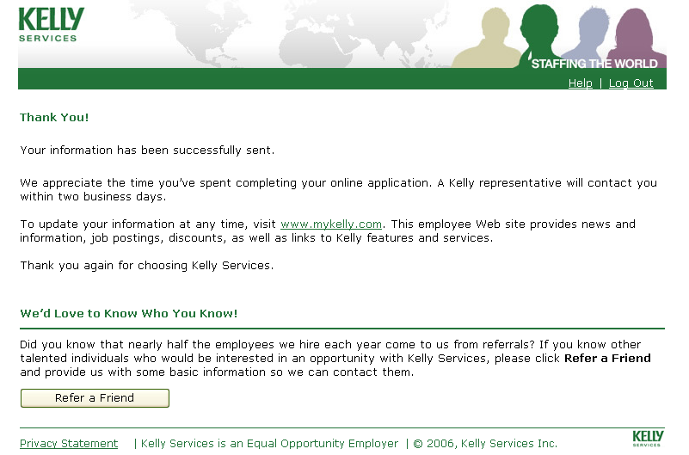  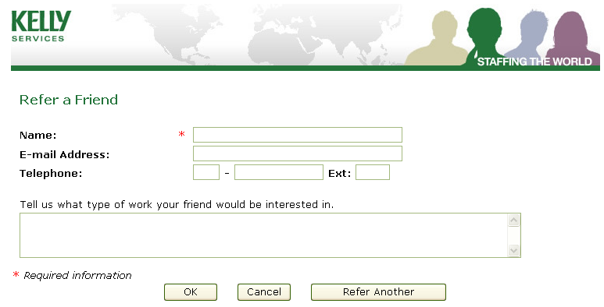
Questions/Contact
If you have questions related to the Online Application System, contact Kelly’s Hotline IT Service Desk at 1-800-KELLY-28.

